ADDITIONAL INFORMATION
4.3.4 - Institution has facilities for e-content development

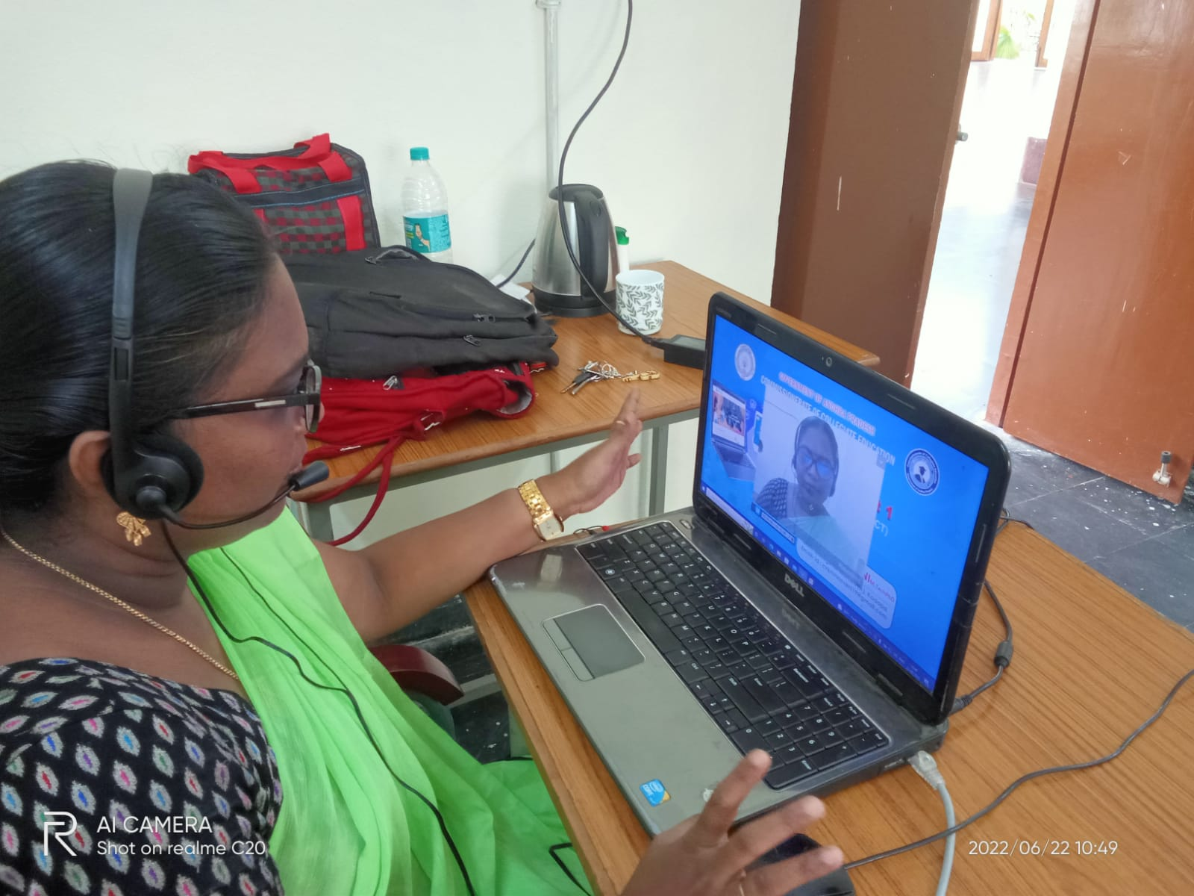

Dr C.V Krishnaveni, Lecturer in Computer Science developed e-content in college by using available resources.

